District or School Information

Each district or school will provide copies of the report available to the public upon request.

State law in Ohio requires each school district board of education and each chartered nonpublic school board or governing authority to adopt and enforce nutrition standards governing the types of food and beverages available for sale on the premises of its schools. Additionally, the board or governing authority must specify the time and place each type of food or beverage is available for sale. The standards specified for beverages and food are minimum standards. Local districts and schools may adopt higher standards.

Each board or governing authority assigns staff to make sure that the district or school meets the nutrition standards in state law. The staff prepares an annual report regarding the district's or school's compliance with the standards. Completion of this survey fulfills the district or school's requirement to report to the Ohio Department of Education its compliance with state law. The board or governing authority must schedule an annual presentation on the report at one of its regular meetings and include the date of the annual presentation in this survey.

* 1.1RN:

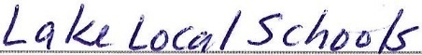
* 2. Organization Name:

* 3. By checking this option I attest that...

·The district or school named above has adopted and is enforcing a nutrition standards policy that considers the requirements of
Ohio Revised Code 3313.814 and governs the types of food and beverages that may be sold on the premises of its school(s).
0 The district or school named above has not adopted and/or is not enforcing a nutrition standards policy that considers the requirements of Ohio Revised Code 3313.814 and governs the types of food and beverages that may be sold on the premises of
its school(s).

Board or Governing Authority Meeting Presentation

* 4. Date of board or governing authority meeting presentation:

MM DO yyyy
Date 10-17-2022

* 5. Name of district or school staff person responsible for ensuring that the school district or school meets the nutrition standards as required by law:
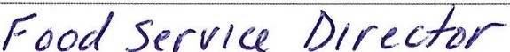
Name: Dave Lloyd
Title:

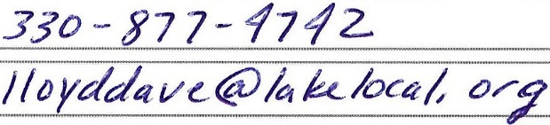
Phone Number: Email Address:

